**Alm Lab Anaerobic Chamber Protocols**

**Coy Laboratories contact:**

Andy Dickey

Principal

Biomedical Sales Consultants (BSC)

Cell:  617 833-1112

Email:  [Andy@biomed-sales.com](mailto:Andy@biomed-sales.com)

Kevin Coy

734-475-2200

kevin@coylab.com

Chad Brown

734-475-2200

chad@coylab.com

**Anatomy of the hood:**

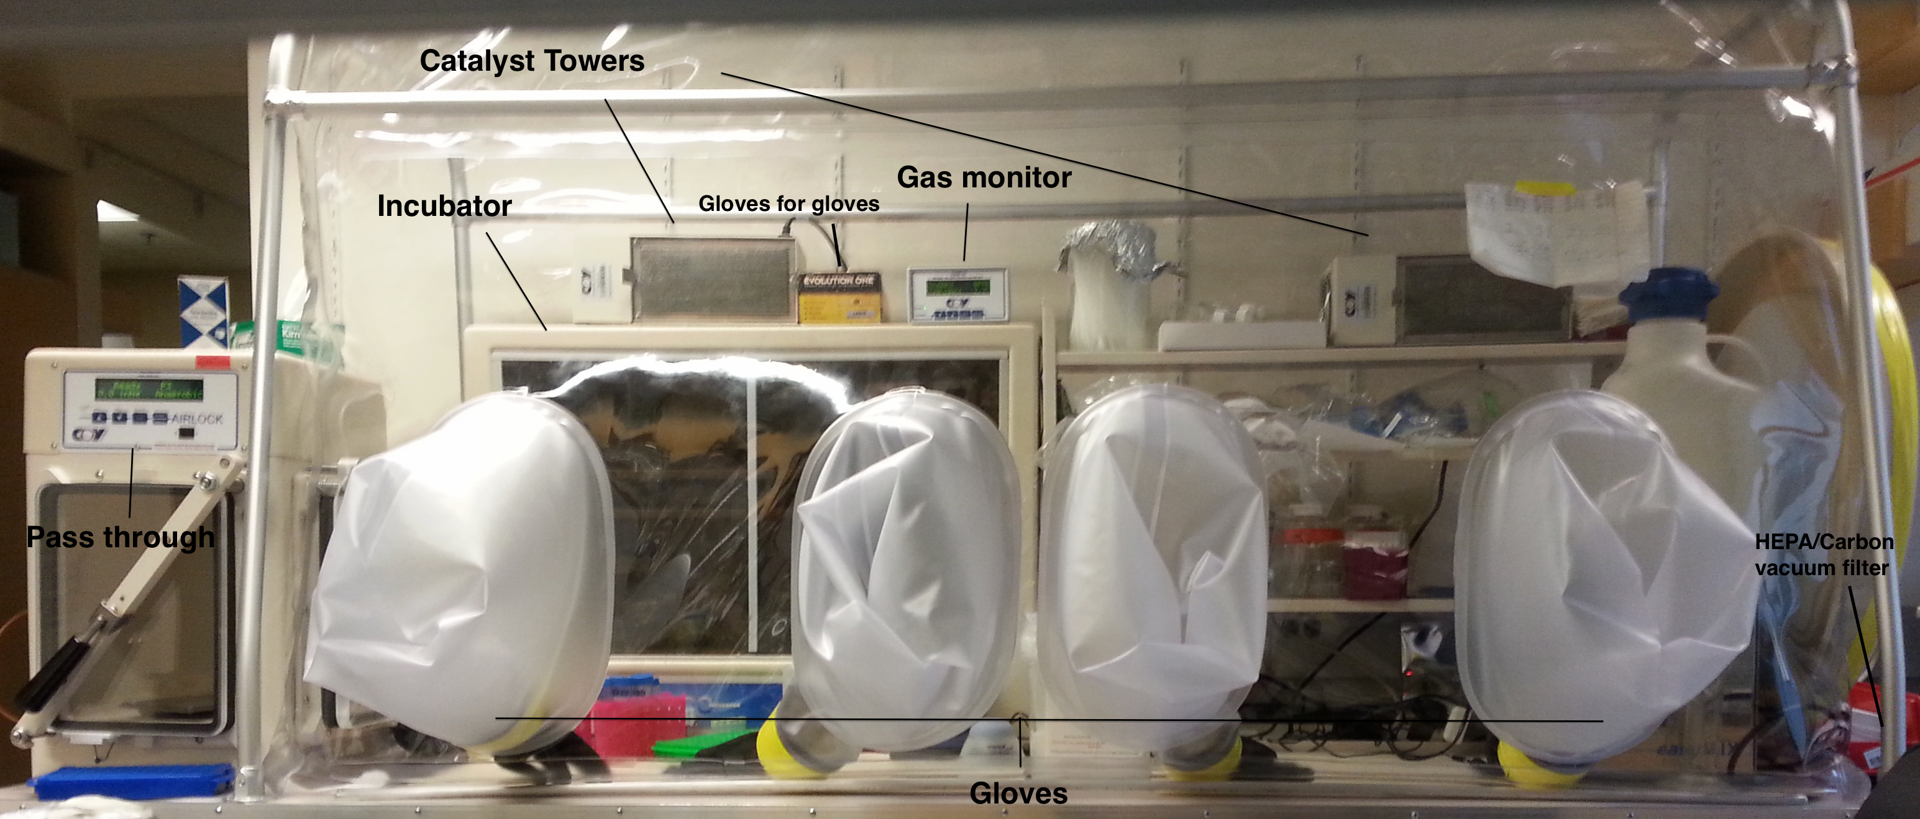

**Precautions**

The chamber is for culturing bacteria from *healthy* human fecal material, and is therefore Biological Safety Level 2 .

Users must wear gloves and a lab coat. When manipulating stool or culture in the chamber, users must put a pair of gloves over the black chamber gloves.

All waste should be removed immediately after generation. After culturing isolates, surfaces should be decontaminated with 70% ethanol.

After manipulation of raw stool, the HEPA filter/carbon filter pump to the right of the chamber should be switched on, surfaces should be decontaminated with 10% bleach and allowed to sit for 30 minutes. Then wipe surfaces with 70% ethanol.

Exchanging of gas tanks is limited to approved senior users, and requires eye protection. Adjust gas regulators such that 20 PSI is maintained while gas is in active use. It is okay if the regulator pressure is higher/lower during down time.

**Chamber Components:**

Environmental gas mixture – 5% Hydrogen, 20% Carbon dioxide, balanced with Nitrogen. This mixture takes ~3weeks to come in so there should always be a backup tank stocked in the lab.

Gas monitor – monitors Oxygen (PPM) and hydrogen (%) in chamber, if change balance of hydrogen, nitrogen, or Carbon dioxide in gas mixture used in chamber you will need to re-calibrate the monitor

Catalyst tower – Uses palladium to scrub air of oxygen, needs to be baked in the incubator at 300 degrees for 3 hours when used up.

**General Use:**

The hood shall be stocked with:

* 10% bleach; dilute bleach solution should be no more than one week old.
* 70% ethanol; dilute ethanol solution should be no more than 4 months old.
* Paper towels
* Small BL-2 waste bin
* Small autoclave bags that fit waste bin
* Latex gloves (size large; any brand).
* Drierite desiccant

Note: **Materials take time to reduce in the chamber**. Agar plates and large volume bottles of buffer/media that contain a reducing agent can be left in the chamber over night to reduce. Smaller volumes of buffer/media should be sparged for 30minutes with nitrogen as needed.

* Place items in pass through then press start to cycle pass through
* When pass through beeps and says anaerobic you can open the inside door and bring in items
  + **Do not open inside door if pass through does not say anaerobic**
* Small oxygen spikes will occur in the chamber when you open the pass through.
  + **Anything under 75ppm is ok, >75 ppm get lab manager**
* **Hydrogen levels should be maintained at or above 2%**
  + Should see depletion of hydrogen over a few days. If it is just holding the same level even with passes please tell Ali
* **If you have processed a bulk fecal sample in the chamber run the HEPA/carbon filter for 30 to 45 minutes during bleach/ethanol cleanup**.
* Spray gloves and work surface with 10% bleach after every use. Let bleach sit for 20 minutes before wiping up.
* After bleach treatment spray areas with 70% ethanol.

**Gassing Chamber**

* **Make sure pass through is anaerobic**
* Open inside door
* Hit the menu button on the pass through
* Hit the start button to select Manual mode
* Vacuum the chamber until the top of the vinyl touches the top of the catalyst towers
* Then fill with either Nitrogen (if oxygen levels are high) or Environmental mix (if hydrogen is low)
* Repeat two above steps (vaccum and fill) 2-3 times
* Gas monitor takes a few minutes to calibrate so you should see the gas levels start to adjust after 3 cycles

**Refreshing catalyst in catalyst tower:**

* Catalysts must be baked every week in 300 C oven (the Alm lab makes use of the Voigt lab oven)
* Remove trays and bake them for 3 hours in the Voigt lab oven at setting 4, extras may be stored in the oven.
* The oven is located in the basement of NE47 in room 015
  + The code to this room is 4+5-1

**Weekly maintenance:**

* Change catalysts
* Gas chamber with environmental gas
* Change DryRite (usually needed but don’t change if still blue)
* Change bleach
* Run HEPA/carbon filter for 30 to 45 minutes

**Checking for H2S build up:**

* Hydrogen sulfide (H2S) can build up in the hood and imped the growth of certain organisms as well as corrode electrical components.
* The carbon filter helps to remove some of this build up.
* To check for the presence of H2S use lead(II) acetate paper (Millipore cat# 1.09511.0003, stored in the drawers below the chamber)
* Pass through and then tape up a piece of lead(II) acetate paper in the hood. Allow 20 minutes to one hour for detection depending on extent of H3S buildup. Note this is a non-reversible indicator.

**Changing out gas canisters:**

NOTE: only one person in the lab should be doing this to help minimize confusion and risk

* NEVER move gas canisters without the safety controller cap
* Close cap of gas tank so it is closed
* Turn yellow regulator valve handle perpendicular to line to close
* Use wrench to remove regulator from tank and place controller cap back on
* Move empty gas canister to wall bracket and exchange for full canister
* Once canister is in place and buckled down, twist off controller cap
* Cut off plastic wrap
* Screw on regulator
  + NOTE: Environmental gas tanks are reverse threaded so Left = tighty and Right = loosy
* Turn knob on tank to open flow of gas to regulator
* Regulators should be around 20 psi
* Checking gas connection:
  + Check tank level while tank is open and regulator is closed. Open regulator, the tank level should remain the same
  + Turn off pass through and use manual gas switches at back of pass through to check the flow of the gas. Make sure the psi is between 15 20 and that is doesn’t drop when you stop flowing gas (watch it for about 30 seconds to make sure)
  + Listen for hissing at the joining of the regulator and the tank, the regulator and the copper line, along the copper line, and at the joining of the copper line and the pass through.